**ECOM20002**

**Forecasting in Economics and Business**

**Tutorial 8**

1. Let $ε_{t}$ be a sequence of innovations that behaves according to an ARCH(1) process,
$$ε_{t}=σ_{t}υ_{t}$$

$$σ_{t}^{2}=α_{0}+α_{1}ε_{t-1}^{2}$$

$$υ_{t}\sim _{i.i.d.}\left(0,1\right)$$

$$α_{0}>0, α_{1}≥0$$

2. Show that $ε_{t}$ is serially uncorrelated. That is, verify that all of its autocorrelations (apart from its zero-th autocorrelation) are zero.

**First we show that**

$$E\left[ε_{t}ε_{t-1}\left|Ω_{t-1}\right.\right]=ε_{t-1}E\left[ε_{t}\left|Ω_{t-1}\right.\right]$$

**Since $$ε_{t}=σ_{t}υ_{t}$$**

**It must be the case that**

$$E\left[ε_{t}\left|Ω_{t-1}\right.\right]=E\left[σ_{t}υ_{t}\left|Ω_{t-1}\right.\right]=σ_{t}E\left[υ_{t}\left|Ω_{t-1}\right.\right]=0$$

**Therefore**

$$E\left[ε_{t}ε_{t-1}\right]=E\left[ε_{t-1}E\left[ε_{t}\left|Ω_{t-1}\right.\right]\right]=0$$

**The covariance between $ε_{t}$** **and $ε_{t-1}$** **is given by**

$$γ_{1}=E\left[\left(ε_{t}-E\left[ε_{t}\right]\right)\left(ε_{t-1}-E[ε_{t-1}]\right)\right]=E\left[ε_{t}ε_{t-1}\right]=0$$

**Applying the same reasoning to $ε_{t}$ and $ε_{t-j}$** , **we can see that all autocovariances of order $j>0$**  **will be zero and thus all autocorrelations of order $j>0$ will be zero.**

1. Suppose now that $ε_{t}$ behaves according to an ARCH($m$) process. Will $ε_{t}$ be still serially uncorrelated?

**Yes, the derivation in part a.) is unaffected by the order of the ARCH process.**

1. Suppose that $ε_{t}$, in addition to behaving according to an ARCH($m$) process, also represents the innovations to an ARMA($p,q$) process,

$Y_{t}=$ $μ_{t}+ε_{t}$

$$μ_{t}=α+\sum_{i=1}^{p}{ϕ_{i}Y_{t-i}}+\sum_{i=1}^{q}{θ_{i}ε_{t-i}}$$

What are the forecasting implications of incorporating an ARCH($m$) structure into the time series behaviour of $Y_{t}$?

**If the innovations $ε_{t}$ behave according to an ARCH process, then the conditional variance of $Y_{t}$ is no longer constant. We have shown previously that the forecast intervals for an ARMA process are typically computed as functions of the $θ$’s, $ϕ$’s and $σ^{2}$.**

**Since $σ^{2}$ is assumed to be constant, the width of the forecast interval will be the same regardless of whether the most recent past has been particularly volatile or not (i.e., the estimate of $σ^{2}$ is computed using the entire sample).**

**When the conditional variance is time varying, the width of the forecast intervals will depend on the previous innovations since**

$$σ_{t}^{2}=α_{0}+α_{1}ε_{t-1}^{2}+α_{2}ε_{t-2}^{2}+…+α_{m}ε_{t-m}^{2}$$

**This means that when an extreme event occurs (i.e. a large shock/innovation), the forecast interval will widen. In reality, especially in financial markets, extreme events create additional uncertainty. The widening of forecast intervals in response to these shocks are a good way of capturing this phenomena.**

**Thus, the forecast intervals generated from ARCH and GARCH models are dynamic in the sense that their width will depend on how volatile the most recent past has been.**

1. The file “btc.csv” contains observations of the daily closing price of Bitcoin from 08/05/2016 to 08/05/2019. Using ***R*** you are required to do the following:
2. Generate the daily returns on Bitcoin as the log difference of the daily price.



1. Verify using the sample ACF and PACF, as well as appropriately specified Box tests that the daily returns are serially uncorrelated.



 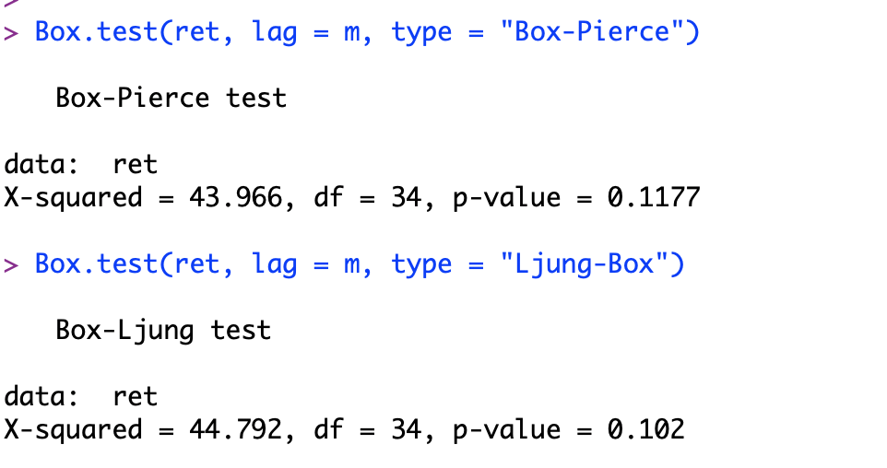

1. Using the methods described in the lecture, test for the presence of ARCH effects in the daily Bitcoin returns.









**The sample ACF and PACF for the squared returns indicate the existence of serial correlation. This is supported by the Box-tests and LM test on the squared returns.**

1. Estimate an appropriate ARCH model for the returns. Verify that your ARCH specification is adequate by plotting the standardized residuals from your ARCH estimation.

**The ARCH model that minimizes the AIC and BIC is an ARCH(6), see R code.**



The sample ACF and PACF and the Box-tests on the squared standardised residuals from the ARCH estimation verify that we have accounted for all the dependence in the conditional variance!





